**WAN Setup with Wired and Wireless LANs in Packet Tracer**

1. 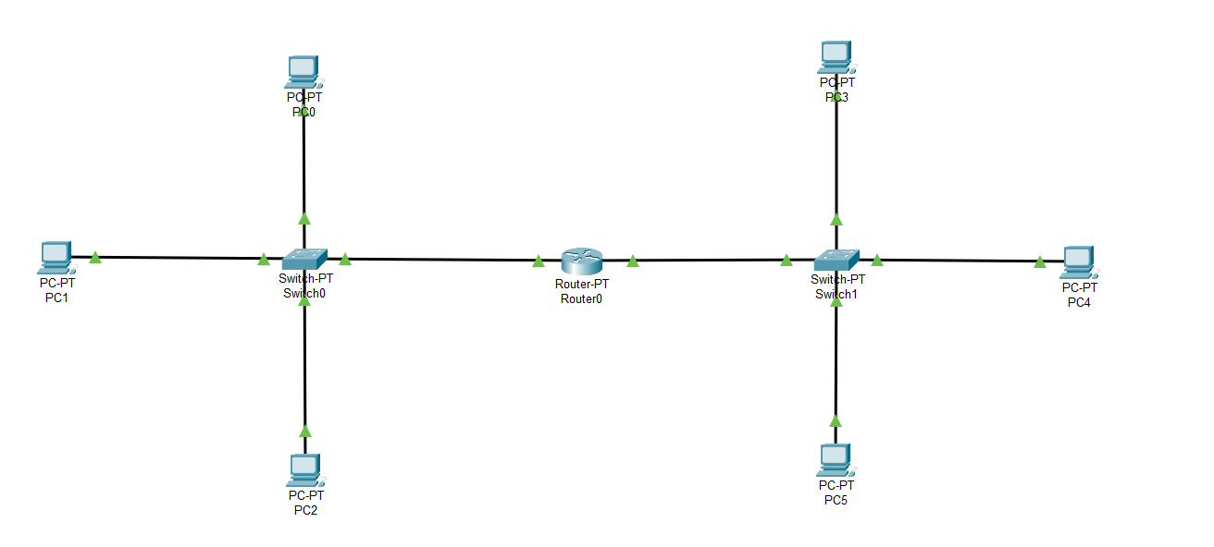**Wired-to-Wired LAN Communication via WAN**
2. **Wireless-to-Wireless LAN Communication via WAN**

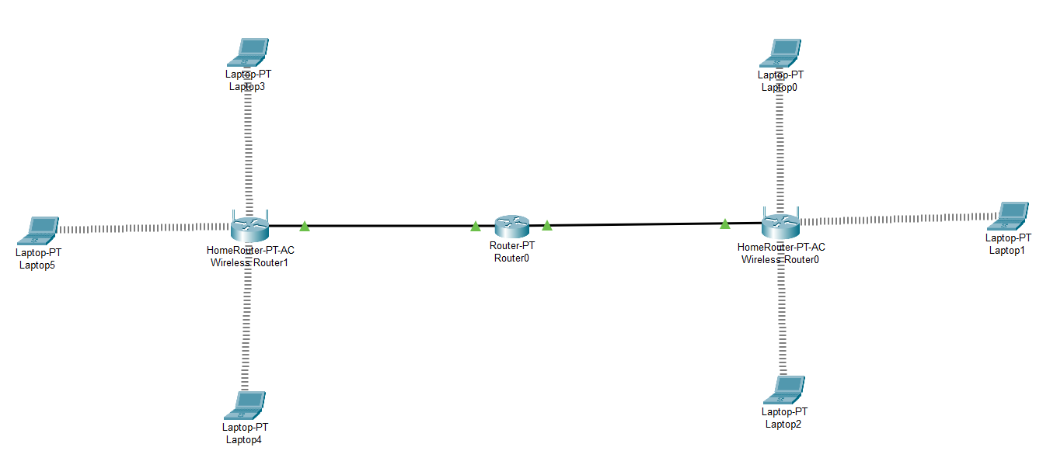

1. 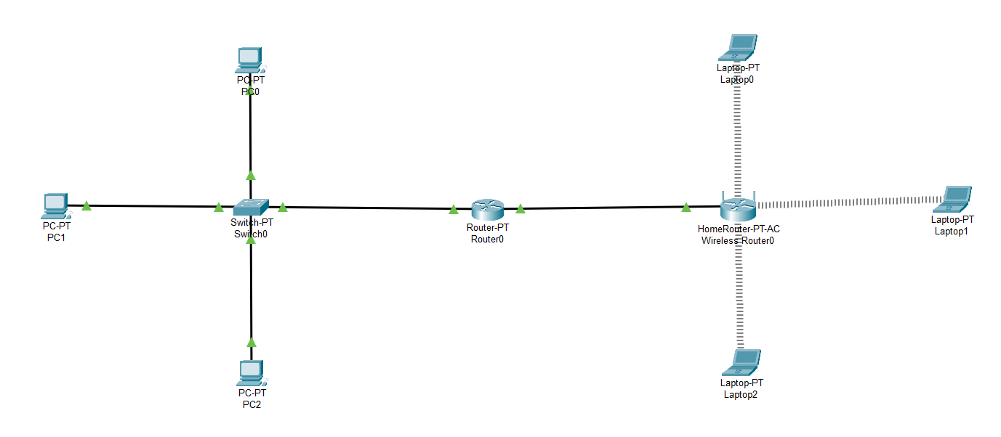**Wired-to-Wireless LAN Communication via WAN**